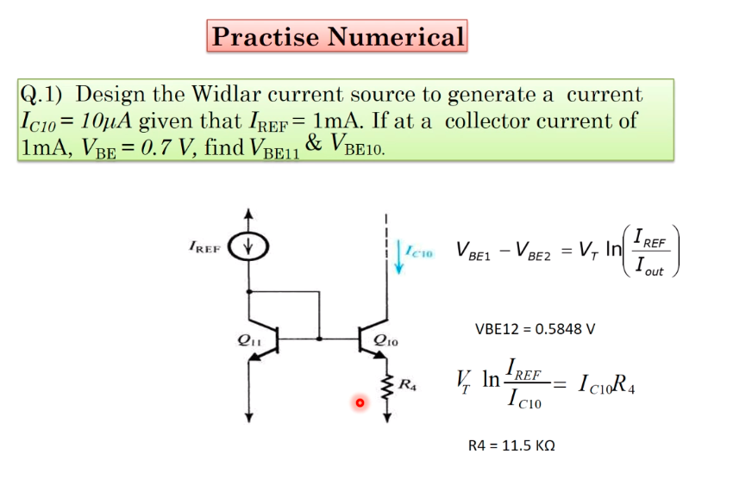

0

**IDENTICAL TRANSISTOR**: Physical and thermal properties should be same.